CA 1 Assignment



Student Number as per your student card: Ravindher Ashokan 20063604
Course Title: M.Sc. Cyber Security
Lecturer Name: Swati Dongre
Module/Subject Title: Advanced Programming Techniques
Assignment Title: CA_ONE_ (30%)
No of Words: 526 Words

GitHub Link - https://github.com/Ravindher133/Programming-CA1.git

TABEL OF CONTENT

- Introduction
- Program 1 – Contact Book Application (C#)
2.1 Contact list
- Program 2 – File Extension Information System (C#)
3.1 Valid & Invalid Extension
- Program 3 – College Admission Number Generator (Python)
4.1 Server details
4.2 Client details
- Program 4
5.1 Scraping
- Conclusion
- References

- Introduction
This document will discuss the implementation and ensuing result outputs pertaining to four programming assignments done using C# and Python. Also, every task will detail the objective, functionality, and result outputs. The screenshots included within this document will be regarding result outputs.
- Program 1 – Contact Book Application (C#)
The first program is to implement a console-based contact book system. The main objective is to permit the user to store, view, update, and delete the records of contacts. The application provides a menu-driven interface where users can input the details and perform operations on the stored contact list.
2.1 Contact list
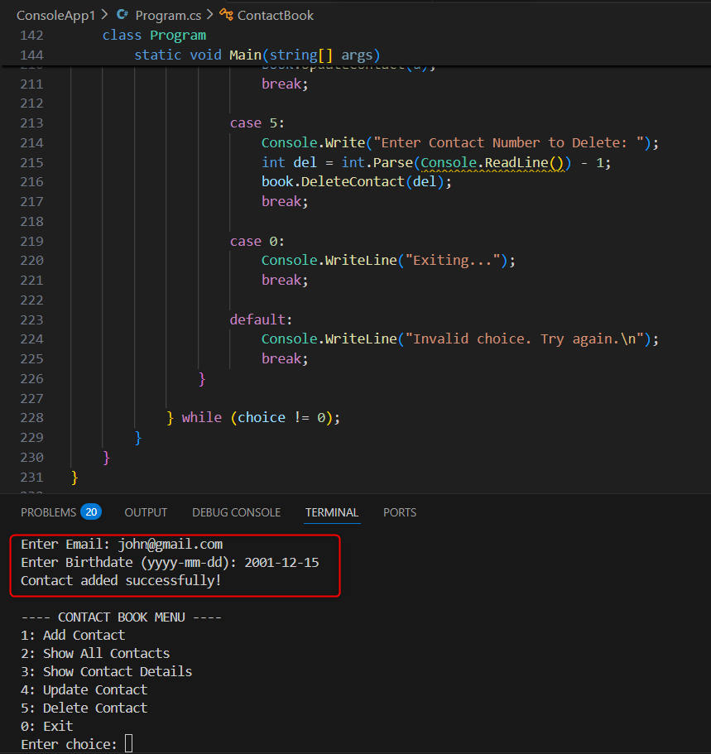
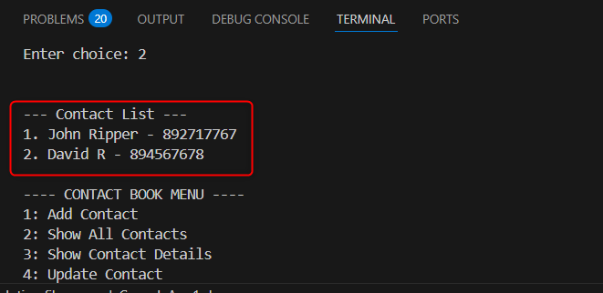
Figure 2.1.1 Contact book list output

- Program 2 – File Extension Information System (C#)
This program defines a meaning for various file extensions. The program is executed and based on a prompt; the user has to enter a file extension. In case the extension exists on the system, the description of that corresponding file will appear; otherwise, the program will notify the user that the extension is not recognized. Hint: typing ‘exit’ will terminate the program.
Ex: below
.mp4 -> Video File
.pdf -> Document
.jpg -> Image
3.1 Valid & Invalid Extension
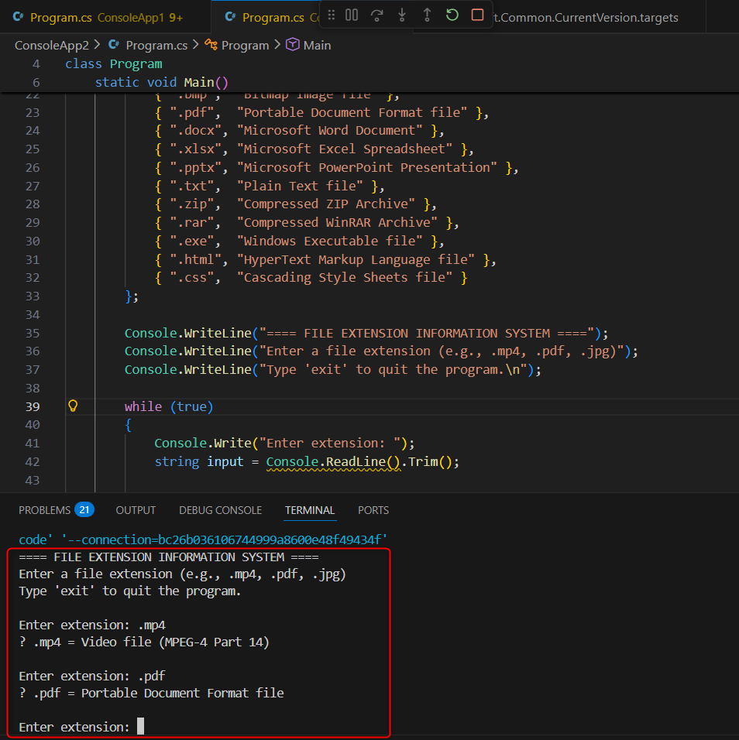
Figure 3.1.1 Valid Extension output
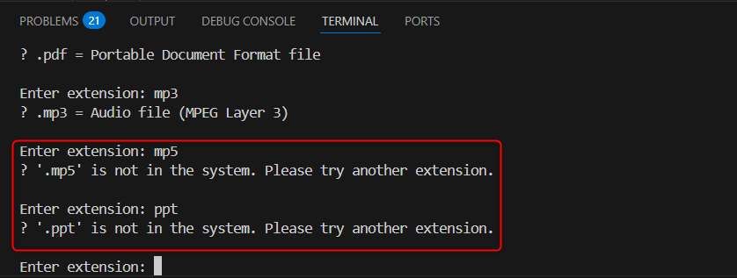
Figure 3.1.2 Invalid Extension output

- Program 3 – College Admission Number Generator (Python)
The third program develops an admission system within a client-server network. The server listens on a given port and creates unique admission numbers. The client captures user responses and transfers them to the server for it to return an admission number.
4.1 Server details
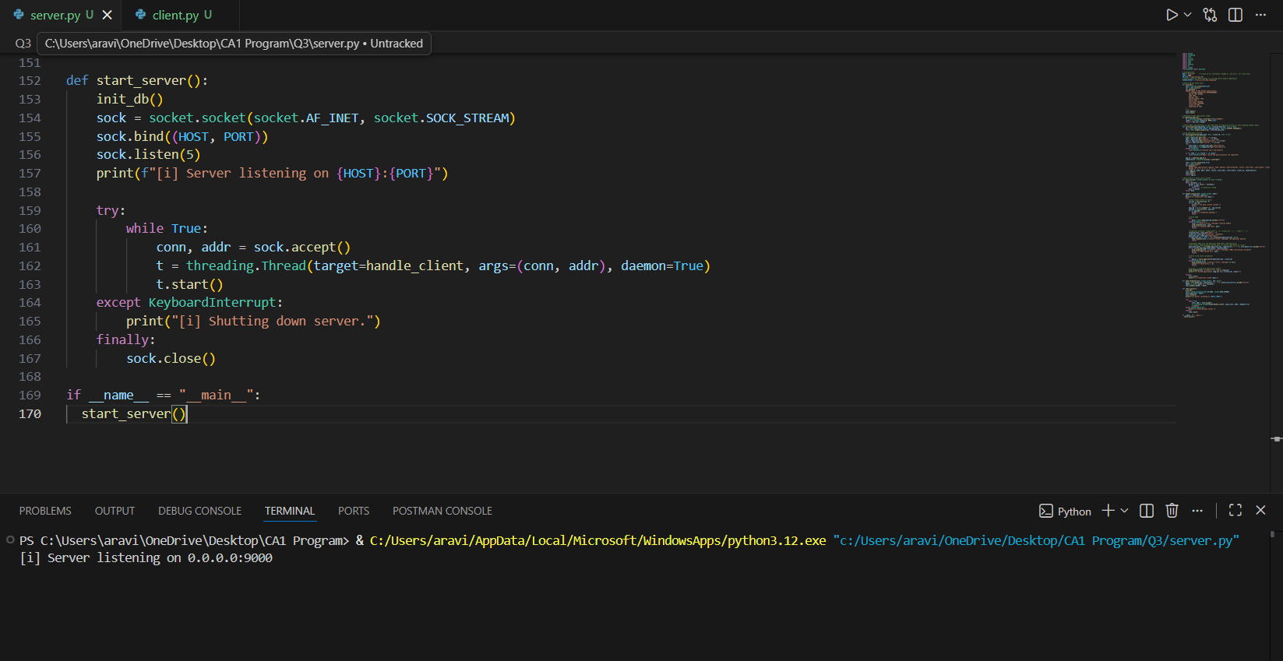
Figure 4.1.1 Server output

4.2 Client details
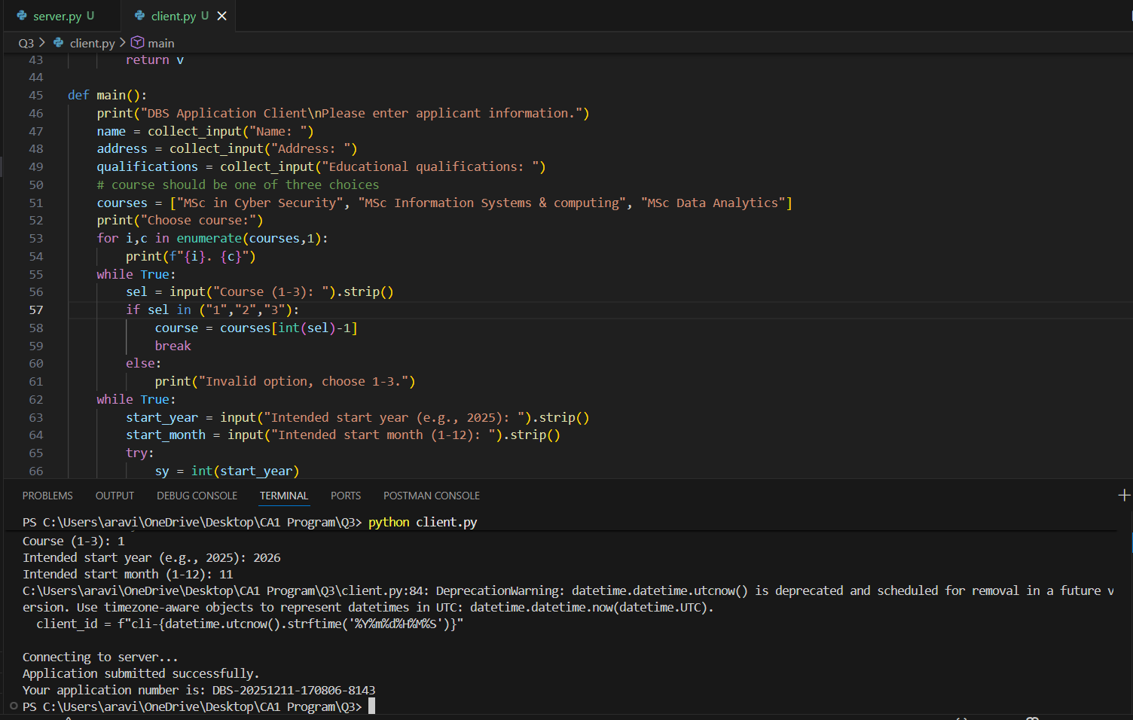
Figure 4.2.1 Client Output
- Program 4 – Web Scraping and Comparative Analysis (Python)
Within this program, techniques for web scraping have been incorporated to analyze data obtained from the ‘Books to Scrape’ website. The functions of these scripts include acquiring data on books such as titles, prices, and reviews. It then proceeds to analyze these sets of data.
5.1 Scraping
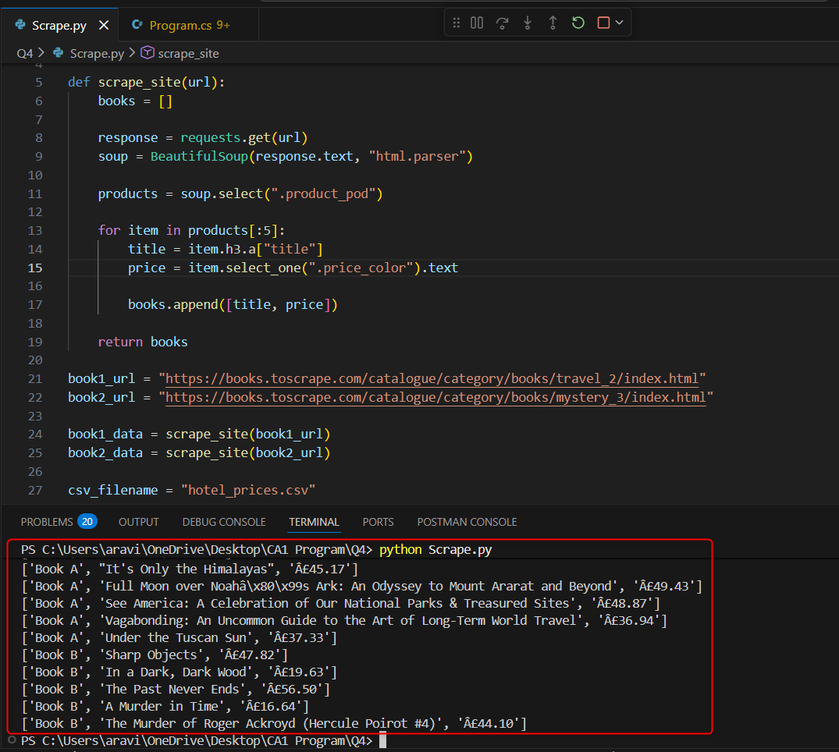
Figure 5.1.1 Scrape Output

- Conclusion
This CA really helped me to get a deeper understanding of both C# and Python. Working with C# significantly improved my problem-solving skills because the assignment needed thorough requirement analysis and detailed implementation of each task. This process also enhanced my ability to understand and interpret project requirements effectively. While working with Python, I furthered the practical knowledge of database concepts and integration.

- References
Amos, D. (2024)’ A practical introduction to web scraping in Python’. Available at: https://realpython.com/python-web-scraping-practical-introduction/.
Fullstack Dev (2020) ‘C# From scratch: Phonebook console application’. Available at: https://www.youtube.com/watch?v=D9xNawxQoTM.
Manwani, H. (2021) ‘How to create and use the Dictionary in C#’. Available at: https://www.loginradius.com/blog/engineering/how-to-create-and-use-dictionary-csharp.
‘3 Best ways to get a file extension in Python (With Examples)’. Available at: https://www.index.dev/blog/get-file-extension-python. (no date)
‘Travel | Books to Scrape – Sandbox’. Available at: https://books.toscrape.com/catalogue/category/books/travel_2/index.html. (no date)

